KA2, project #europehome
Intensive Programme
Entrepreneurship skill teaching and training programme

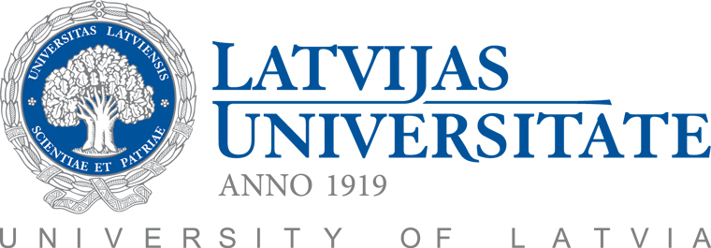
Venue: Riga, Latvia (hosted by the University of Latvia)
Dates: 18-23 July, 2016
Target group: Academic and Administrative Staff
Deadline to apply: March 15, 2016

The Intensive Programme will provide an opportunity to share and exchange best practices with colleagues from other institutions and learn more about innovative university-business cooperation schemes (at an administrative and academic level).
The scope of the course is broad and it is aimed at increasing skills, sharing methodologies and tools to improve work effectively as well as at encouraging to apply new cooperation models among university staff members.
Core areas of the Intensive Programme are:
- 21st century methodology of entrepreneurship skill training
- Innovative settings to trigger entrepreneurial and transversal competences
- Effective information management, optimization of internal and external communication flows, increased collaboration of university staff members and usage of modern technologies
Certification: Certificates will be awarded at the end of the programme.

Intensive Programme is intended primarily for
- Academics
- Administrative staff coordinating university cooperation with the labour market (career centres, specific projects, business incubators etc.) and international issues (for instance, student mobility).

In brief
Target group | Academic and administrative staff
Duration | 5 days (excluding travel days)
Participation fee | 50 EUR (social programme, accommodation and catering will be covered)
Travel costs | Covered for all nominated participants (up to 200 eur)
Number of places and universities involved | 6 representatives per university  (University of Latvia, University of Aveiro, Lodz University of Technology, Aristotle University of Thessaloniki, University of Alcala)
Application deadline | March 15th , 2016

Application:
For more information, please contact: xxxxxxxxx Please insert the Name/Surname and contact details of the respective coordinator
LV: Kristine Berzina
PL: Agnieszka M.
ES: Antonio Guerrero
PT: Elisabeth Pereira
EL: Stella Kostopoulou
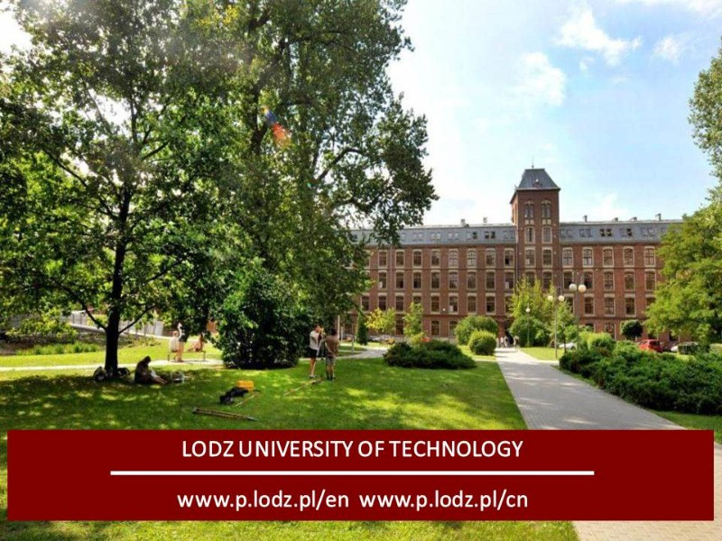
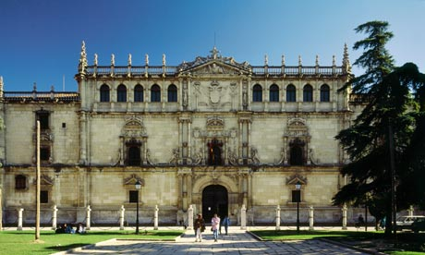
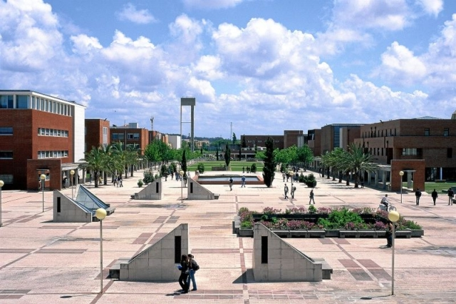
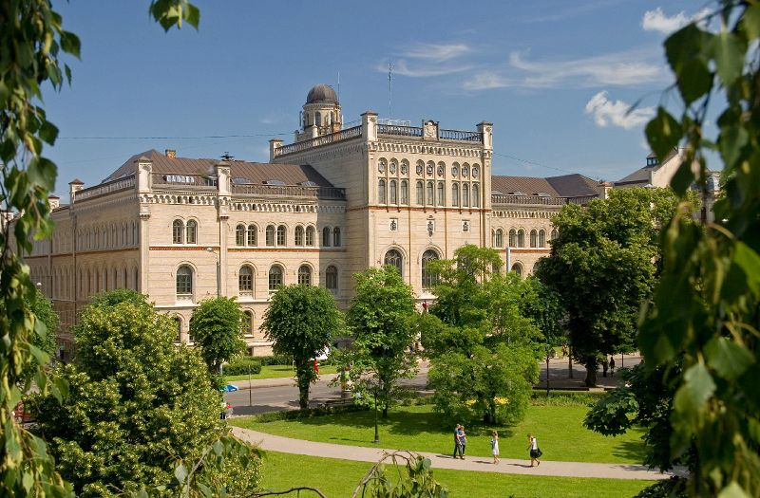
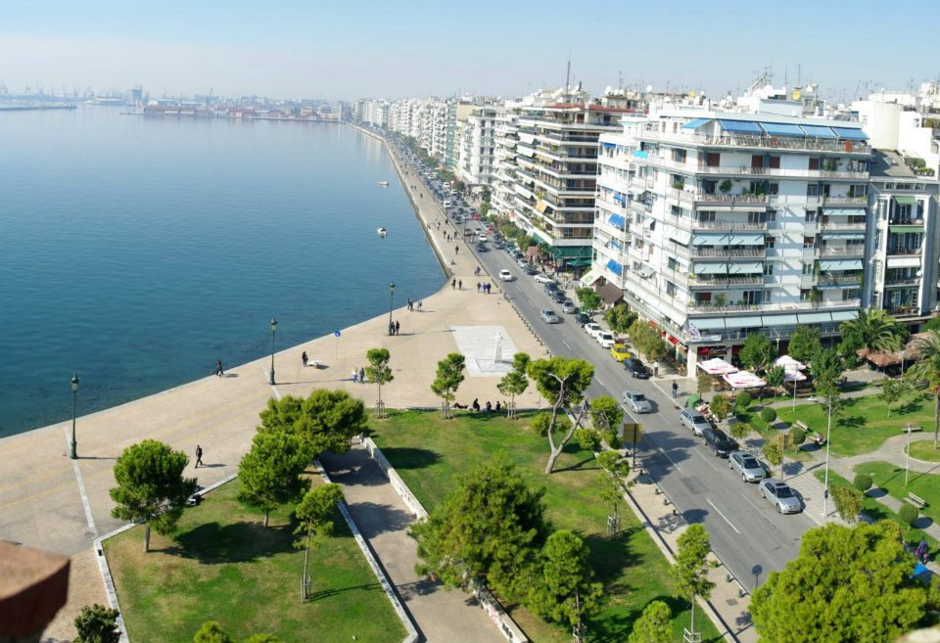
More information: www.europehome-project.eu

