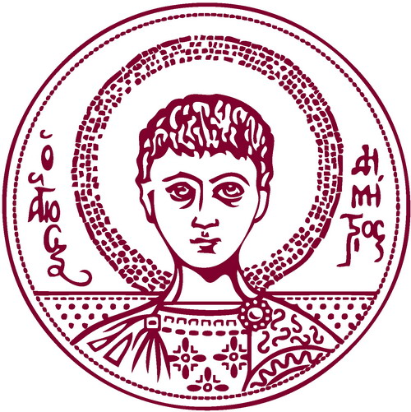 |   ARISTOTLE UNIVERSITY OF THESSALONIKI  STAFF MOBILITY FOR TEACHING  TEACHING CERTIFICATE  Academic Year 2022-2023

Name of teaching staff member:
HOME Institution: | ARISTOTLE UNIVERSITY OF THESSALONIKI
ERASMUS code: | G THESSAL01
HOST Institution:
Department/Faculty:
ID Erasmus code:
Subject area code:

Number of teaching days (min. 2 consecutive days): _________

Total number of teaching hours (min. 8 hours per week): __________

First date of teaching: _____/_____/_____

Last date of teaching: _____/_____/_____

Teaching Language: _________________________________________
Level of students: Undergraduate 
Postgraduate 
Doctoral 
Combination 

Number of students benefiting from the teaching programme: _______

Content of the teaching programme:

 | Name | Signature | Date | Stamp
Dean/President/Head of the Faculty of Host Institution

Please complete and return this form after the visit to:

Department of European Educational Programmes tel.: +30-2310-995294
Aristotle University of Thessaloniki

GR-54124, Thessaloniki, Greece e-mail: erasmus-financial@auth.gr

